A000-AM,S-Peru-Moche-Figurine-Male-Seated-with Hand to Mouth 100 BCE-400 CE

Figs. 1-4-AM,S- Peru-Moche-Figurine-Male-Seated-with Hand to Mouth 100 BCE-400 CE

**Case no.: 9**

**Accession Number: A000**

**Formal Label:** Peru-Moche-Figurine-Male-Seated-with Hand to Mouth 100 BCE-400 CE

**Display Description:** This Moche figurine from the N coast of Peru dating to the Mochica II Period, 100 BCE-400 exhibits a tantalizing problem in understanding. What is the figure protecting with his right hand covering his mouth? Is it the beginning manifestation of the jaguar transformation? Seated males may imply with the right hand on the mouth a transforming figure, but both eyes are wide-open. This is, therefore, a rather enigmatic posturing. Bracelets and Anklets in jade suggest a certain élite social position or status. He also wears a bi-lobal cap which also may indicate his rôle.

.

**LC Classification: F3430.1.**

**Date or Time Horizon:** 100 BCE-400 CE

**Geographical Area:** N coastal Peru

**Map, GPS coordinates: -6.80139 -79.60202; 6º48'5" S 79º36'7.28" W.**

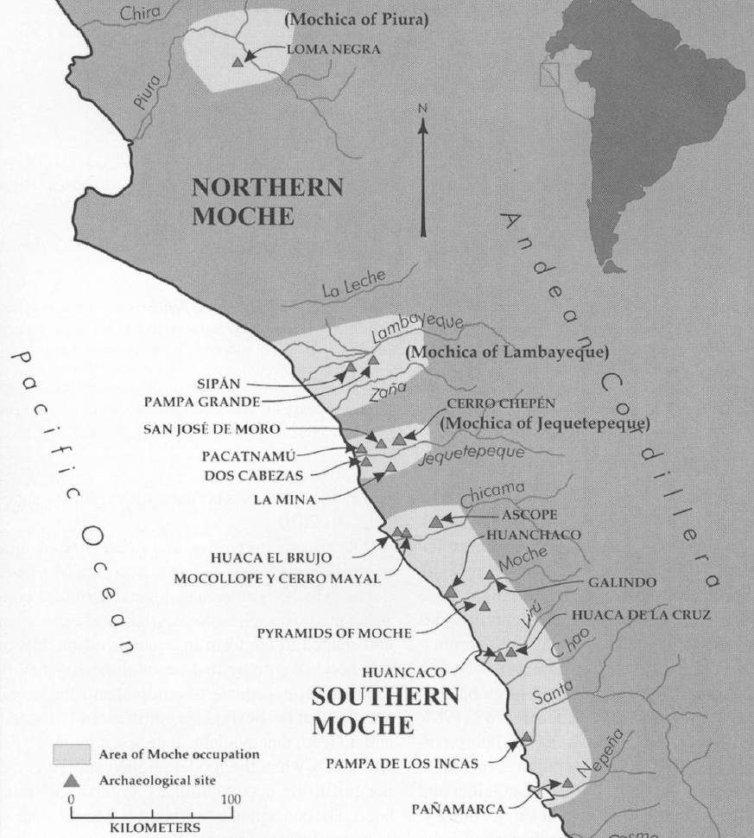

Fig. 5. Map of Moche regions as currently conceived and significant Moche sites. Map courtesy Moro Archaeological program.

**Cultural Affiliation:** Moche, Mochica

**Medium:** copper

**Dimensions:** H mm; in

**Weight: gm; oz**

**Condition: original**

**Provenance:** unknown

**Discussion:**